EXPERIMENT – 8

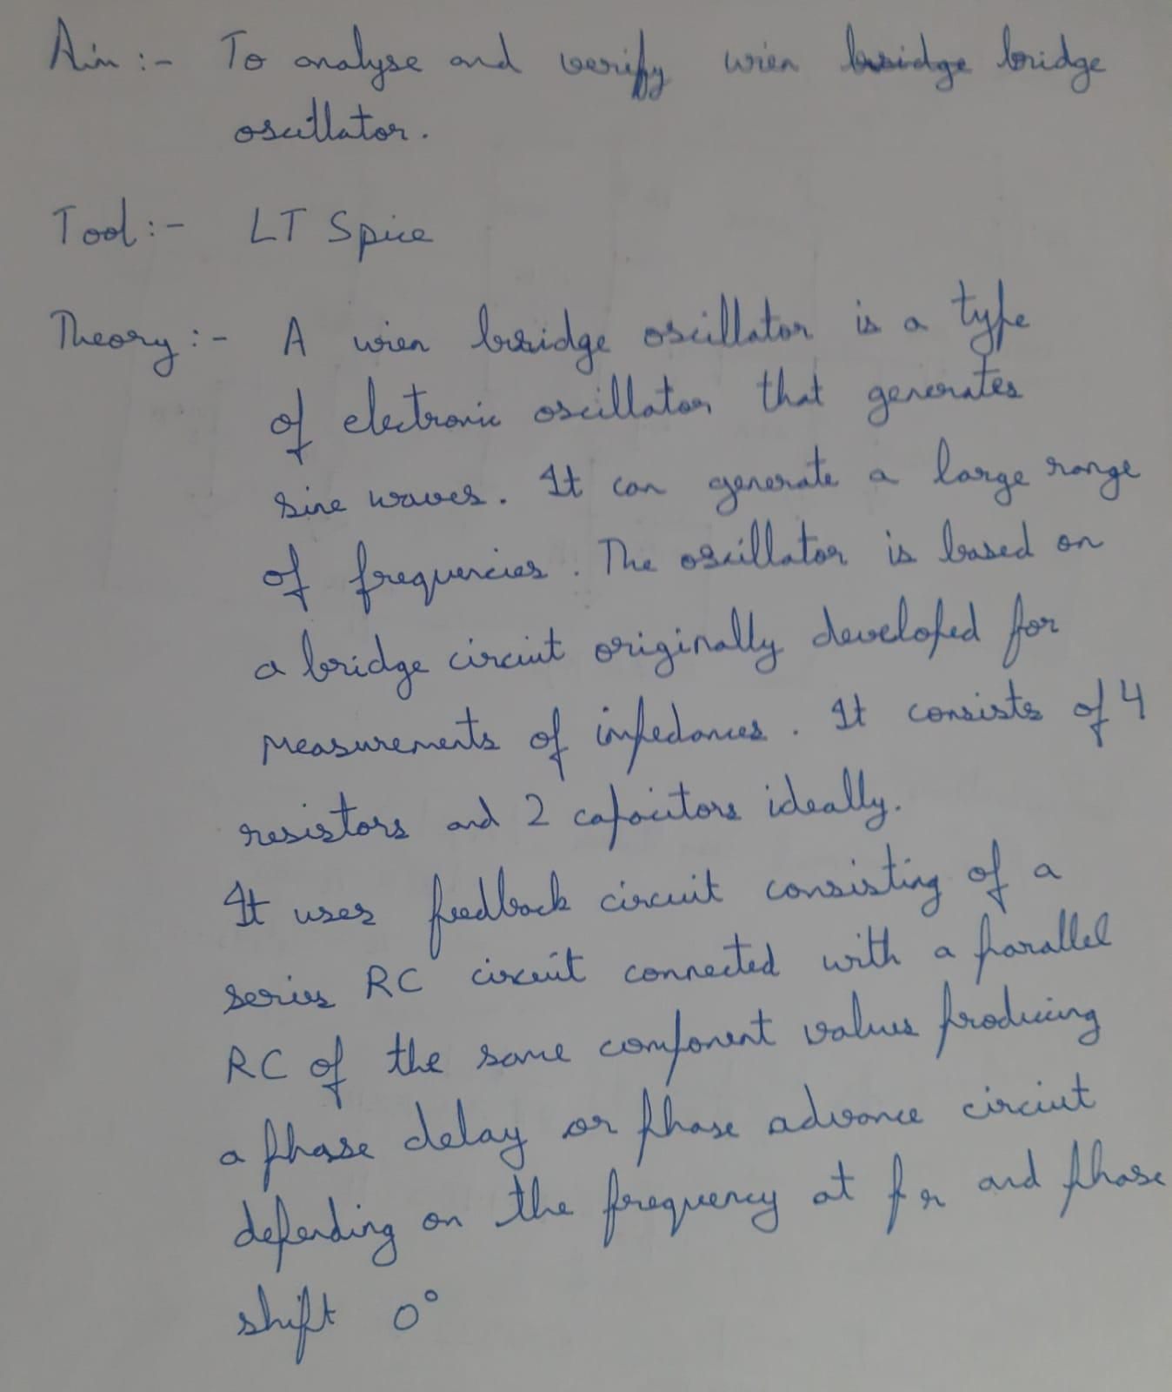

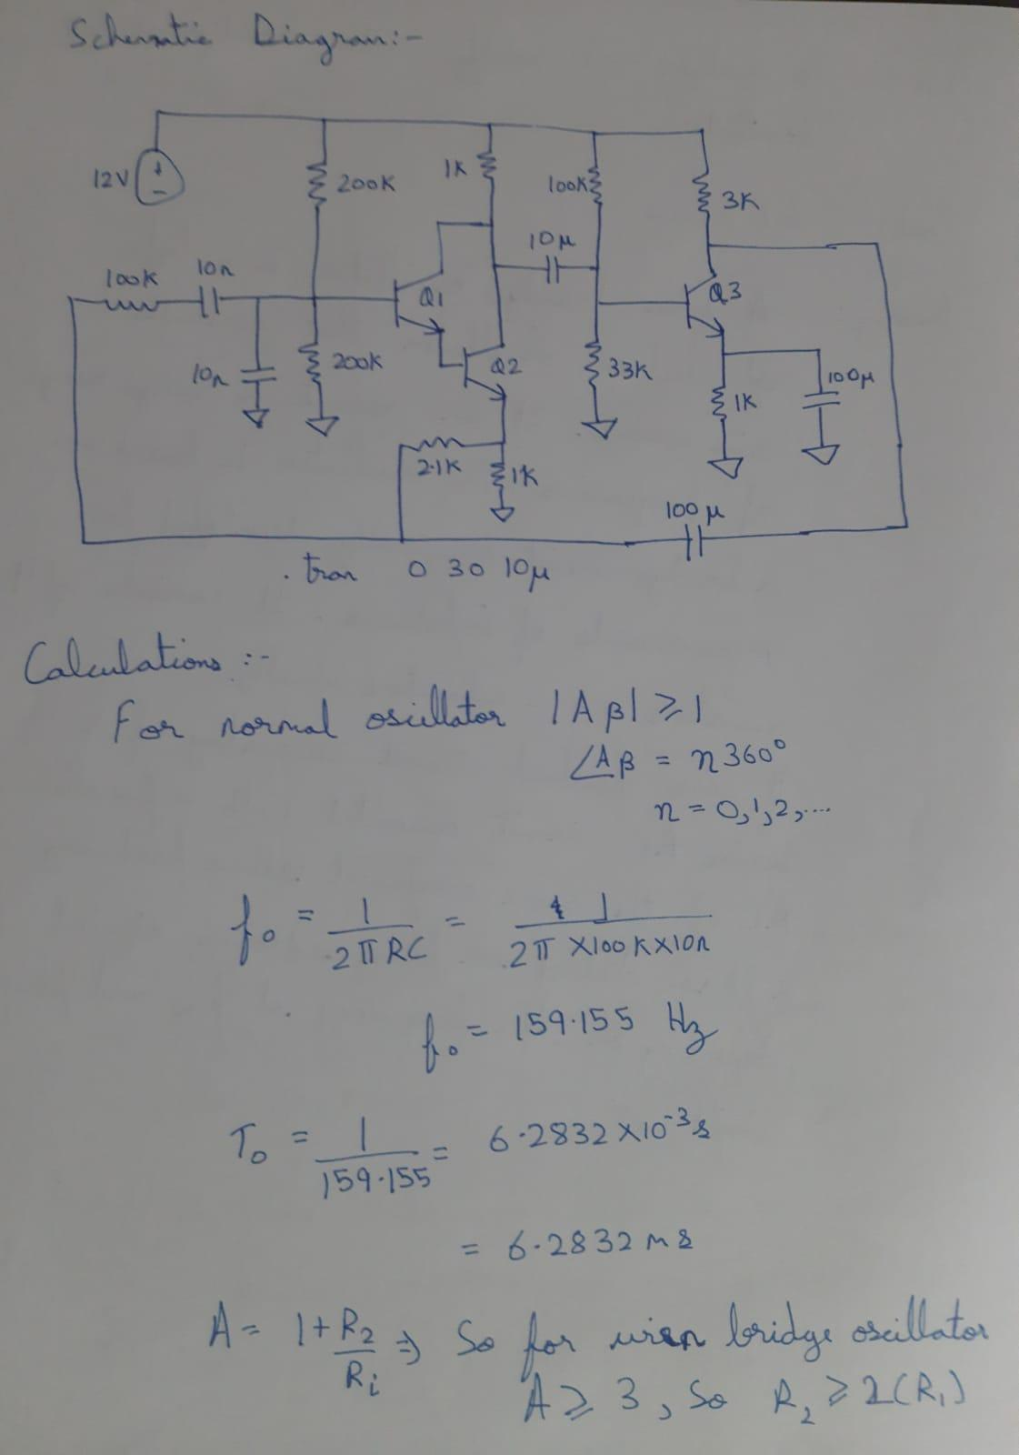

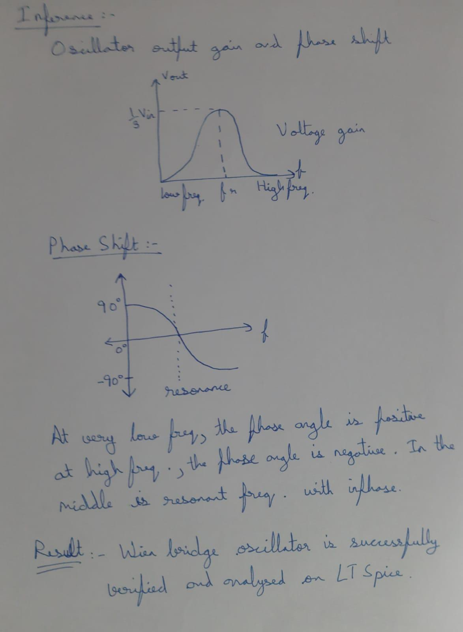

CIRCUIT: -

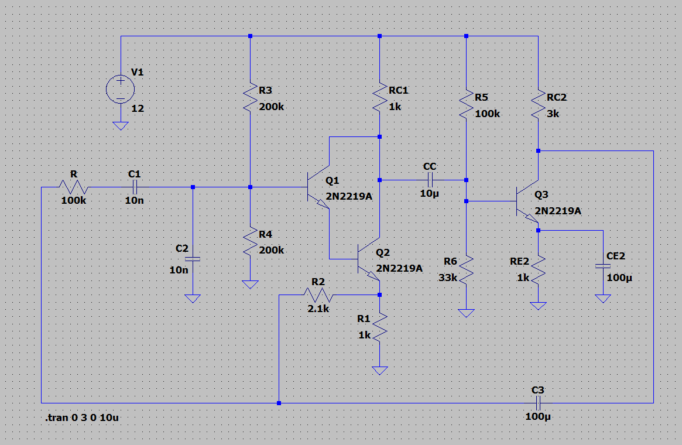

OUTPUT: -

STEADY STATE: -

